Use Case Realisation Report (Design) - Register Volunteer Account
FOR
Volunteer Management SystemVolunteer Management System
(VMS)

CLIENT | Liu Peishan
PROJECT | Volunteer Management SystemVolunteer Management System (VMS)
TITLE | Use Case Realisation Report (Design) - Register Volunteer AccountUpdate profile
VERSION | 0.1b0.1a
DATE | 13-Aug-2011
 | ORIGINATOR
 | Name / Signature | Team 8S
 | APPROVAL
 | Name / Signature | Phung Kim Cuong, Dio
Institute of Systems Science |  | Document Reference
25 Heng Mui Keng Terrence  Singapore 119615 |  | VMS/T-1.5.4/1VMS/T-1.4.1/1

 | Acceptance
 | Customer Signature |  | Customer Signature
 | Name & Designation |  | Name & Designation
 | Date & Company Stamp |  | Date & Company Stamp

Revision History

Date | Version | Description | Author
12-Jun-2011 | 0.1a | Creation | Team 8S
29-Dec-2011 | 0.1b | Updates | Team 8S

Table of Contents

1. Brief Description 3
2. Flow of Events 3
2.1 Standard Flow 3
3. Interaction Diagrams 4
3.1 Sequence Diagram: Register Volunteer Account 4
4. Class Diagram 5
5. Derived Requirement 5
ANNEX D Amendment History 7

Use Case Realisation Report (Design) - Register Volunteer Account

Brief Description
The use case describes the new volunteer account registration of VMS system.

Flow of Events
The standard flow of events and alternative flow of events for this use case and any exceptions are described in the following subsections. The events are described in terms of Actors, Design Objects and object operations.

Standard Flow
Refer to the sequence diagram.

Interaction Diagrams

Sequence Diagram: Register Volunteer Account
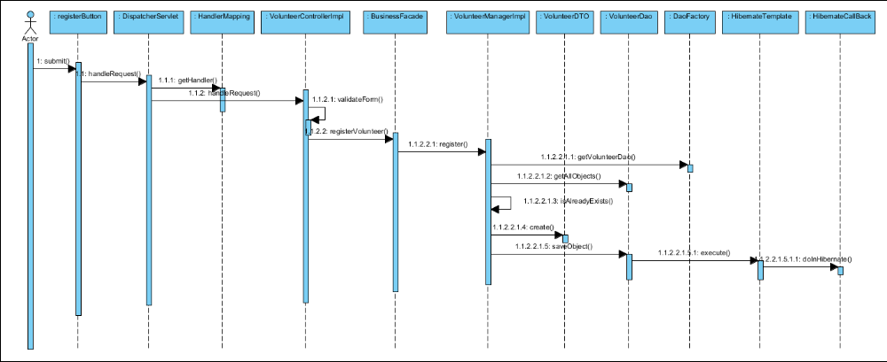
Figure 1 – Sequence Diagram: Register Volunteer Account

Class Diagram
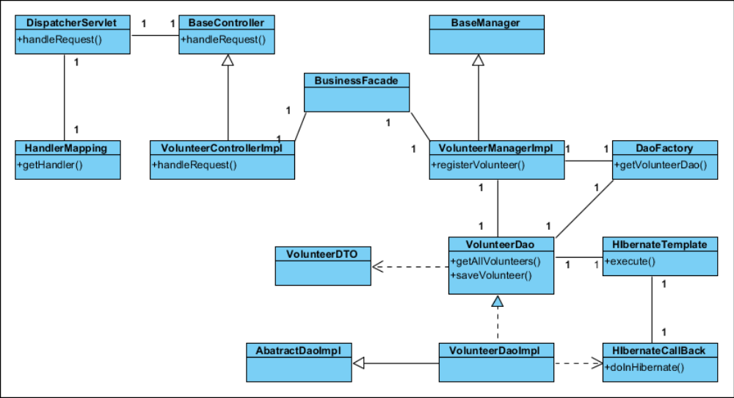
Figure 2 – Class Diagram

Derived Requirement:
User must have these following:
- PC / Handheld / Computing device
- Compatible Web browser
- Mouse, keyboard

ANNEX D Amendment History

This is a record of all amendments made to the Document.
Version | Chapter / Section | Page No | Notes of Amendments or Changes

